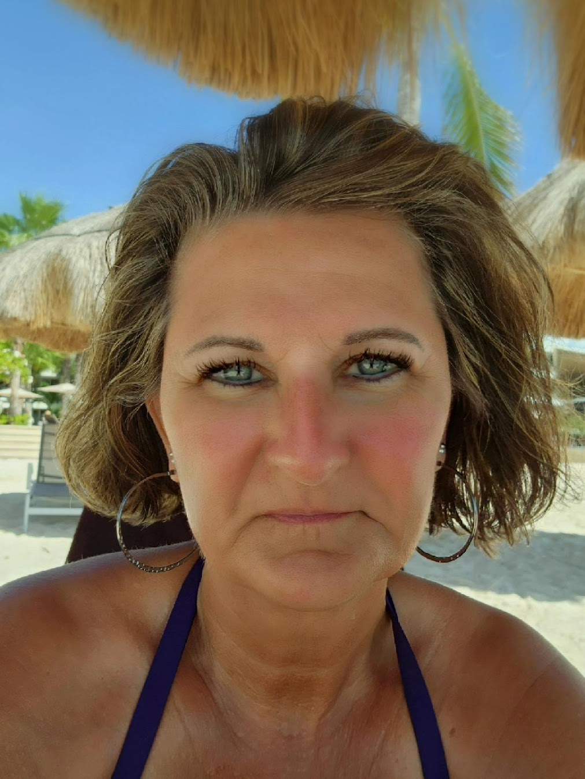
Brenda Kay Bays, 63, of Sun City Center, FL, formerly of Muncie, passed away on Saturday, February 7, 2026, at LifePath Hospice House in Ruskin, FL. She was born on September 14, 1962, in Muncie, IN, to Walter and Shirley (Dungan) Caldwell.
Brenda graduated from Delta High School in 1980. She worked many years as a Collector at many banks and collection agencies. After being diagnosed with terminal Neuroendocrine cancer in 2014, she retired. Brenda deeply loved her family, friends, and numerous animals that she and Greg had over the years. She loved to sit on the beach and listen to the waves. Brenda was a Hoosier at heart, loving her games of cornhole and euchre. She was a beautiful and loving wife, mother, and friend.
A message from Greg: “She is my Love of a Lifetime, my One in a Million, and my Endless Love. She will always be in my heart, and I will love her till the end of time…”
Brenda is survived by her loving husband, Greg; son, Daryl (Leslie) Bays; daughter, Tiffany Bays; grandchildren, Sheridan Bays, Ellianah Bays, Dalilah Bays, and Za’Tavion Smith; adopted grandson, Malachi Bays; great-grandchild, Aria Bays; brothers, Lynn Caldwell and Troy (Shelly) Caldwell; sister, Rhonda Sides; and father-in-law, Harold Bays.
She was preceded in passing by her parents, Walter and Shirley Caldwell; brother, Mickey Caldwell; and mother-in-law, Patricia Bays.
A committal service will be held at 2 pm on Monday, February 16, 2026, in the North Chapel of the Elm Ridge Mausoleum, with Brenda’s cousin, Marty Wright, officiating. Burial will follow in Elm Ridge Memorial Park. Friends may visit with the family from 10 am until the time of the committal, at Elm Ridge Funeral Home. In lieu of flowers, memorial contributions may be made to the American Cancer Society, the Moffitt Cancer and Research Center in Tampa Florida, or per Brenda’s request, friends and family may release a balloon on Monday, at the service; for those unable to attend, you may release a balloon around 3 pm on Monday, at your own leisure.
All are welcome to join the family in a Celebration of Life for Brenda that will be held on Tuesday, February 17, 2026, at from 5 pm – 10 pm at the American Legion Post #321 in Yorktown.

